**Name: MODALLA PRANITH REDDY**

**Roll Number: 2420030158**

Lab-9

Configuration of RIP and OSPF using a Cisco network switch, and verify the connectivity

## RIP Protocol

RIP (Routing Information Protocol) is a simple distance-vector routing protocol used in small, internal networks to exchange routing table information between routers using a hop count as a metric for the best path. Routers running RIP send their entire routing tables to neighbours at regular intervals, typically every 30 seconds, to update their routing databases and learn about network topology changes.

## Step-1: Connecting:

* Connect PC0 and PC1 to the Switch0 using the Copper Straight-through cable as follows:

PC0 (Fa0) Switch0(Fa0/1) PC1(Fa0) Switch0(Fa0/1)

* Connect PC2 and PC3 to the Switch01 using the Copper Straight-through cable as follows:

PC2 (Fa0) Switch1(Fa0/1) PC3(Fa0) Switch1(Fa0/1)

* Connect PC4 and PC5 to the Switch02 using the Copper Straight-through cable as follows:

PC4 (Fa0) Switch2(Fa0/1) PC5(Fa0) Switch2(Fa0/1)

* Connect Switch (0/1/2) to Router (0/1/2) using the Copper Straight-through cable as follows:

Switch0(Fa0/3) Router0(Gig0/0) Switch1(Fa0/3) Router1(Gig0/0) Switch2(Fa0/3) Router2(Gig0/0)

## Establishment of a connection between the routers:

1. Click on Router0
2. In the right-side section of the switch, turn the switch OFF
3. Click on Zoom-in and drag and drop two HWIC-2T (which is the left section ) into the switch
4. Turn ON the switch

Note: Do this process for the remaining two routers as well.

* Connect the Routers (0/1/2) using the Serial DTE cable as follows: Router0(Se0/3/0) Router1(Se0/3/1)

Router1(Se0/3/0) Router2(Se0/3/1)

**Final Connected Diagram:**

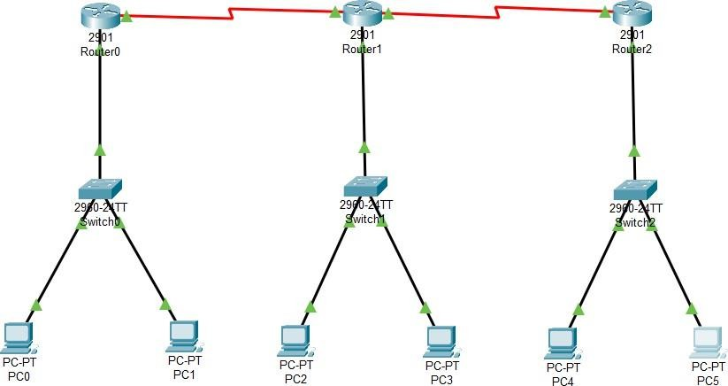

**Step 2: Configuration of the devices**

**Router0:**

* Gig0/0: IPv4 :192.168.1.1

Subnet Mask:255.255.255.0 (Click ON on the top right)

* Se0/3/0: IPv4: 10.0.0.2

Subnet mask: 255.0.0.0 (Click ON on the top right)

## Router1:

* Gig0/0: IPv4 :192.168.2.1

Subnet Mask:255.255.255.0 (Click ON on the top right)

* Se0/3/0: IPv4: 20.0.0.2

Subnet mask: 255.0.0.0 (Click ON on the top right)

* Se0/3/1: IPv4: 10.0.0.3

Subnet mask: 255.0.0.0

## Router2:

* Gig0/0: IPv4 :192.168.3.1

Subnet Mask:255.255.255.0 (Click ON on the top right)

* Se0/3/1: IPv4: 20.0.0.3

Subnet mask: 255.0.0.0 (Click ON on the top right)

# PC0:

IPv4 :192.168.1.2

Subnet Mask:255.255.255.0

Default Gateway: 192.168.1.1

# PC1:

IPv4 :192.168.1.3

Subnet Mask:255.255.255.0

Default Gateway: 192.168.1.1

# PC2:

IPv4 :192.168.2.2

Subnet Mask:255.255.255.0

Default Gateway: 192.168.2.1

# PC3:

IPv4 :192.168.2.3

Subnet Mask:255.255.255.0

Default Gateway: 192.168.2.1

**PC4:**

IPv4 :192.168.3.2

Subnet Mask:255.255.255.0

Default Gateway: 192.168.3.1

# PC5:

IPv4 :192.168.3.3

Subnet Mask:255.255.255.0

Default Gateway: 192.168.3.1

## Step 3: RIP Routing Router0:

* Click on Router0
* Go to the configuration terminal
* Click on the RIP
* Add the network IDs 10.0.0.0 and 192.168.1.0

## Router1:

* Click on Router1
* Go to the configuration terminal
* Click on the RIP
* Add the network IDs 10.0.0.0 20.0.0.0

192.168.2.0

## Router2:

* Click on Router1
* Go to the configuration terminal
* Click on the RIP
* Add the network IDs 20.0.0.0 192.168.3.0

## Step 4: Checking the ping command

* By seeing the output of the ping command, we can know whether the RIP Protocol experiment is successful or not.
* By using the first PC IP address, let's use the ping command in the command prompt of the last PC
* Click on the PC5
* Go to the desktop
* Open command prompt
* Type the command: ping 192.168.1.2

## Output:

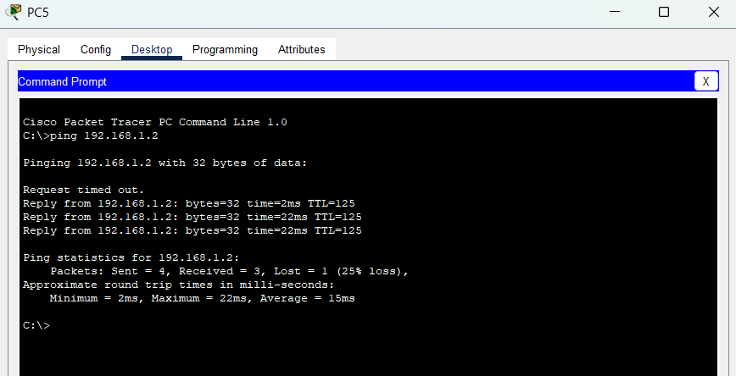

**OSPF Protocol**

OSPF (Open Shortest Path First) is a link-state routing protocol used in medium to large enterprise networks. Unlike RIP, which uses hop count, OSPF uses **cost (based on bandwidth)** as its metric. Each router maintains a link-state database and uses the Dijkstra algorithm to calculate the shortest path tree. OSPF supports hierarchical routing using areas, fast convergence, and efficient resource utilization.

## Step 1: Arranging and Connecting the Devices Arranging:

* **Routers:** Select three routers of type 2901 (Router3, Router4, Router5 in diagram).
* **Switches:** Select two switches of type 2960-24TT.
* **PCs:** Select two PCs.

## Connecting:

* Connect **PC2 → Switch0 → Router3 (Fa0/0)**
* Connect **PC3 → Switch1 → Router5 (Fa0/0)**
* Establish serial connections between routers:
  + Router3 (Se3/0) ↔ Router4 (Se3/0)
  + Router3 (Se2/0) ↔ Router5 (Se3/0)
  + Router4 (Se3/0) ↔ Router5 (Se2/0)

**Final Connected Diagram:**

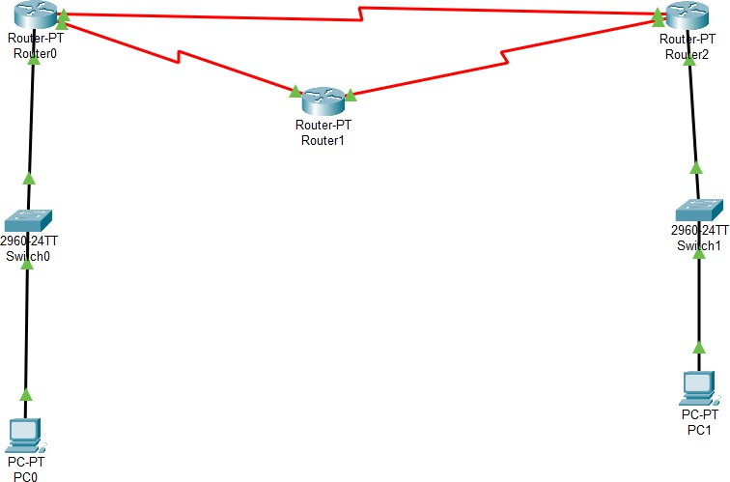

**Step 2: Configuration of the Devices Router0**

* **Fa0/0:**
  + IP: 192.168.10.1
  + Subnet Mask: 255.255.255.0

## Se3/0:

* + IP: 20.0.0.1
  + Subnet Mask: 255.0.0.0

## Se2/0:

* + IP: 10.0.0.1
  + Subnet Mask: 255.0.0.0

## Router1

* **Se3/0:**
  + IP: 10.0.0.2
  + Subnet Mask: 255.0.0.0

## Se2/0:

* + IP: 30.0.0.1
  + Subnet Mask: 255.0.0.0

## Router2

* **Fa0/0:**
  + IP: 155.165.1.1
  + Subnet Mask: 255.255.255.0

## Se3/0:

* + IP: 30.0.0.2
  + Subnet Mask: 255.0.0.0

## Se2/0:

* + IP: 20.0.0.2
  + Subnet Mask: 255.0.0.0

# PC0

* **IP:** 192.168.10.2
* **Subnet Mask:** 255.255.255.0
* **Default Gateway:** 192.168.10.1

# PC1

* **IP:** 155.165.1.2
* **Subnet Mask:** 255.255.255.0
* **Default Gateway:** 155.165.1.1

## Step 3: OSPF Routing Router0

Router3> enable

Router3# configure terminal Router3(config)# router ospf 1

Router3(config-router)# network 192.168.10.0 0.0.0.255 area 0

Router3(config-router)# network 10.0.0.0 0.255.255.255 area 0

Router3(config-router)# network 20.0.0.0 0.255.255.255 area 0

## Router1

Router4> enable

Router4# configure terminal Router4(config)# router ospf 1

Router4(config-router)# network 10.0.0.0 0.255.255.255 area 0

Router4(config-router)# network 30.0.0.0 0.255.255.255 area 0

## Router2

Router5> enable

Router5# configure terminal Router5(config)# router ospf 1

Router5(config-router)# network 30.0.0.0 0.255.255.255 area 0

Router5(config-router)# network 20.0.0.0 0.255.255.255 area 0

Router5(config-router)# network 155.165.1.0 0.0.0.255 area 0

## Step 4: Verifying Connectivity

* Use the **ping command** between end PCs.
* From **PC2 (192.168.10.2)**, ping **PC3 (155.165.1.2)**

C:\> ping 155.165.1.2

Reply from 155.165.1.2: bytes=32 time<1ms TTL=128

If successful, it confirms that OSPF has been configured properly and routing is established.

